

**THYROID DETECTION**

**Project Architecture**

# Domain : Machine Learning

# Creator : Lalatendu Dalai

# Date : 27.12.2023

# Architecture

# Project Architecture

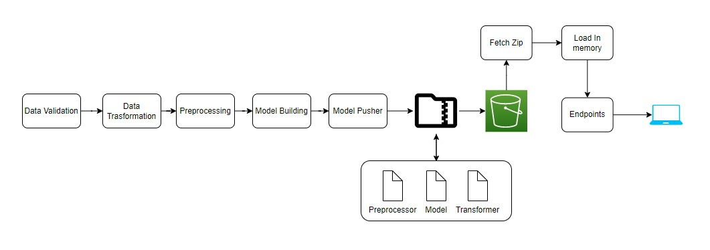

# Deployment Architecture

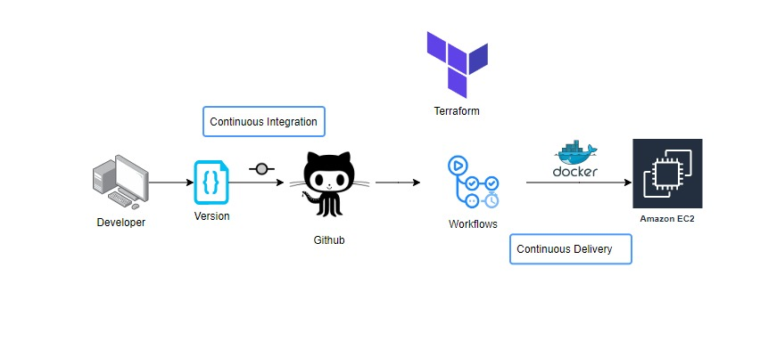

# Architecture Description

# Data Preparation

# Data Description

Thyroid disease is a common cause of medical diagnosis and prediction, with an onset that is difficult to forecast in medical research. The thyroid gland is one of our body's most vital organs. Thyroid hormone releases are responsible for metabolic regulation. Hyperthyroidism and hypothyroidism are one of the two common diseases of the thyroid that releases thyroid hormones in regulating the rate of body's metabolism. The main goal is to predict the estimated risk on a patient's chance of obtaining thyroid disease or not.

# Data Preprocessing

In data preprocessing step, we check if there missing data, duplicate values, and datatypes of each feature. In our dataset, there are some null and duplicate values .

# Exploratory Data Analysis

This step includes bivariate and univariate analysis of features. Checking outliers using boxplots, and outlier treatment is carried out as well. Distribution of the features are plotted to see to what extent our data is skewed.

# Feature Engineering

In this part, the datatypes of the features were checked whether it belongs same datatypes or different datatypes. Outliers were checked using boxplot but there is no such major outliers in the dataset.

# Model Development

# Model Implementation

After train and test splitting, pipeline containing Standard Scaler and Label Encoder was fitted to several models such as DecisionTree Classifier RandomForest Classifier,XGB Classifier, KNeighbors Classifier, etc. Their f1 score were obtained and it was determined that DecisionTree Classifier performs better than other models.

# Model Evaluation

Test dataset is used to evaluate the model 20% of dataset was separated for testing. Predicted results of the model are compared with the actual data to check the amount of error. As there was no considerable change after , it helped us to overcome overfitting and perform better on new data.

# Deployment

# Designing a server

A server should be created to run the UI application continuously. Amazon Web Service EC2 instance is used to create a virtual server for the application.Elastic Compute Cloud (EC2) is a virtual server in AWS for running applications on the AWS infrastructure.

# Code deployment on cloud

The codes for this machine learning model should be deployed to the cloud, so that when data is entered into the application, our code runs, and a user gets the result online.

# Deployment Process

In this stage, we containerized the code using Docker and will be deploying the model to AWS.This is a workflow diagram for the Recipe Recommendation..